**TITLE : FILE SHARING SYSTEM**

**END TERM REPORT**

***by***

**Aashish Kumar , Athira Hemachandran**

Section: K19 PV G:2

Roll Numbers: 51 , 67



**Department of Intelligent Systems,**

**School of Computer Science Engineering,**

**Lovely Professional University, Jalandhar**

31st October 2020

**Student Declaration**

This is to declare that this report has been written by us. No part of the report is copied from other sources. All information included from other sources have been duly acknowledged. We aver that if any part of the report is found to be copied, we are shall take full responsibility for it.

Name : Aashish Kumar , Athira Hemachandran

Roll No. : 51 , 67

Date : 31st October 2020

**TABLE OF CONTENTS**

**TITLE PAGENO.**

|  |  |
| --- | --- |
| **1. Background and objectives of project assigned** | **5** |
| **1.1 BACKGROUND AND MOTIVATION OF THE PROJECT** | **5** |
| **1.2 OUTCOME AND CONCRETE GOALS OF THE PROJECT** | **5** |
|  |  |
| **2. Description of Project** | **6** |
| **2.1 DESCRIPTION** | **6** |
| **2.2 WORK DIVISION AMONG GROUP MEMBERS** | **7** |
| **2.3 IMPLEMENTAION OF THE PROJECT** | **8-11** |
| **2.4 TECHNOLOGIES AND FRAMEWORKS USED** | **12** |
| **2.5 SWOT ANALYSIS** | **13** |

**BONAFIDE CERTIFICATE**

Certified that this project report “ FILE SHARING SYSTEM ” is the bonafide work of “Aashish Kumar and Athira Hemachandran” who carried out the project work under my supervision.

Name :- Dr. Dhanpratap Singh

UMS ID :- 25706

Department :-School of Computer

Science and Engineering

1. **BACKGROUND AND OBJECTIVES OF THE PROJECT ASSIGNED**

**1.1 BACKGROUND AND MOTIVATION OF THE PROJECT :-**

Due to this era of this enormous pandemic , all the majority works which used to be carried out in offices or schools migrated to the respective home of the employees and students and this was given the name of work from home . But as we were sitting too far from each other in different states and countries it was very difficult to share files for all the people whether they were employees or students . So, to resolve this problem me and my partner got an idea to make a system by which we could send our files to anyone in the world . To ensure effective collaboration between colleagues, external staff, service providers and customers, powerful and effective tools are required to simplify communication and enable the seamless exchange of work materials. **File sharing system** enhances teamwork in the company and accelerates workflows.

**1.2 OUTCOME AND CONCRETE GOALS OF THE PROJECT :-**

As an outcome, we will be able to share our files through our system . The main objective of the project is to transfer files from person to person irrespective oh his or her profession. From data sheets to images and text files **file sharing system** is the ideal tool for quick and secure file transfers between colleagues, clients and customers. It allows for large file sharing between **PCs, laptops and mobile devices** in real time.With its powerful capabilities and flexible solutions, this system is well suited for those who regularly or [work from home](https://www.teamviewer.com/en/info/work-from-home/) or remotely: connect to a company PC while on the go and conveniently transfer files to your own device. **File sharing system** has a number of security mechanisms in place to ensure the data exchange is always secure.

1. **DESCRIPTION OF THE PROJECT :-**

**2.1 DESCRIPTION :-**

* Login / Sign Up page :- In this page , users will be able to sign up into our system or if they have already signed up then they will have to login first to use the system .
* About Page :- In this page , we have given the general overview of the project and also a contact section will also be present on this page through wich users will be able to contact us ON whenever they need to.
* Home Page :- In this page users will able to select their files wich they want to share and the people to whom they want to share their files and they can also give the description and file name to their file .
* Shared Files Page :- In this page , the files which we have shared , their name and description and to whom we have shared will be displayed.
* Logout Page :- In this page , users will able to logout from their respective ID’s and then the page will be automatically redirect to the sgnup and login page.
* The login and signup module of the system is provided by the prebuilt Django framework .
* We have applied the CRUD operations on the system which means CREATE , READ , UPDATE and DELETE .
* This system is a file sharing system which has used many components such as Python, SQLite, Django , html , CSS and Bootstrap 4.
* **PICTORIAL WORK FLOW OF THIS PROJECT :-**

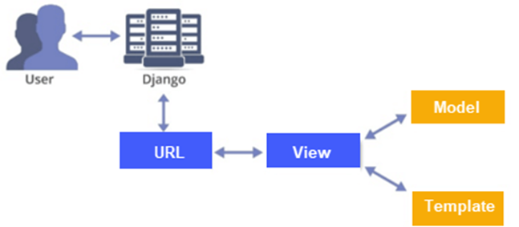

**2.2 WORK DIVISION AMONG GROUP MEMBERS :-**

* **AASHISH KUMAR :-**
* Backend development
* Website development
* Website deployment on server
* Data uploading using http request
* API integration
* **ATHIRA HEMACHANDRAN :-**
* Frontend development
* Interface layout
* Webpage designing using html and bootsrap 4
* Database management using SQLite
  1. **IMPLEMENTAION OF THE PROJECT :-**

**Login page**

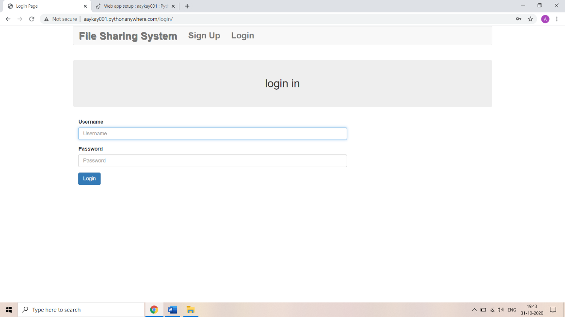

**Sign up Page**

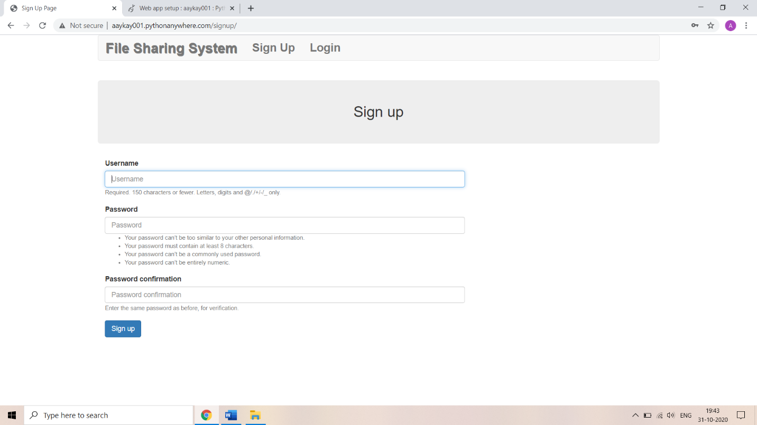

**About page**

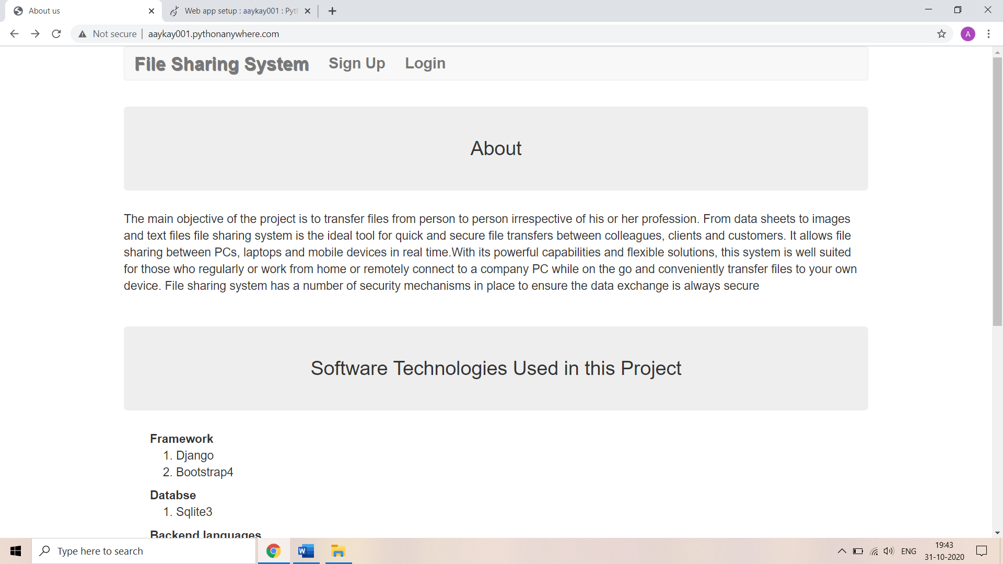

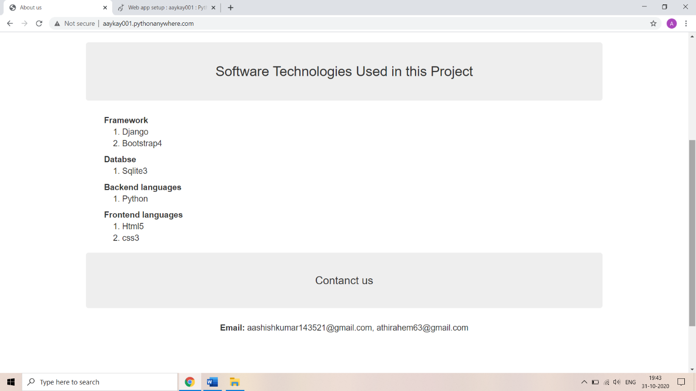

**Home page for uploading a file**

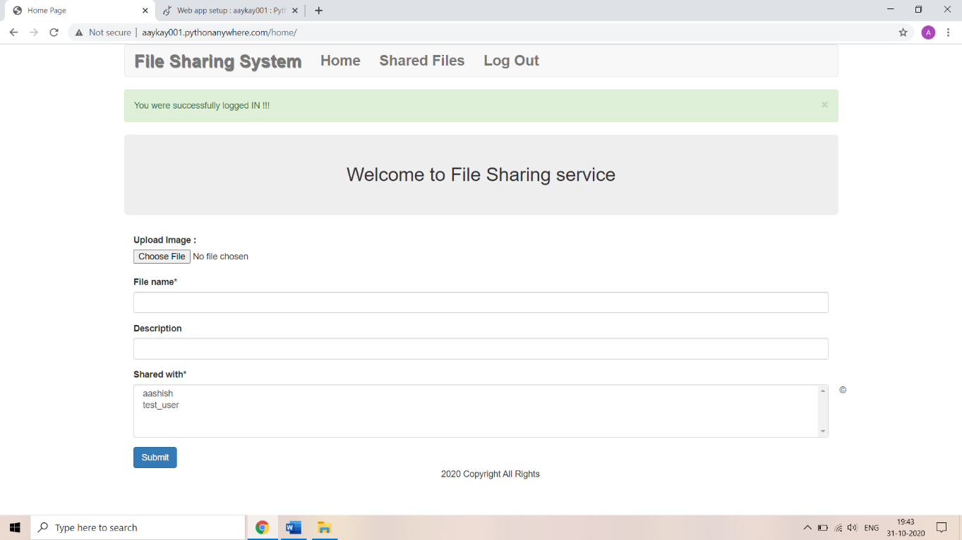

**Admin panel**

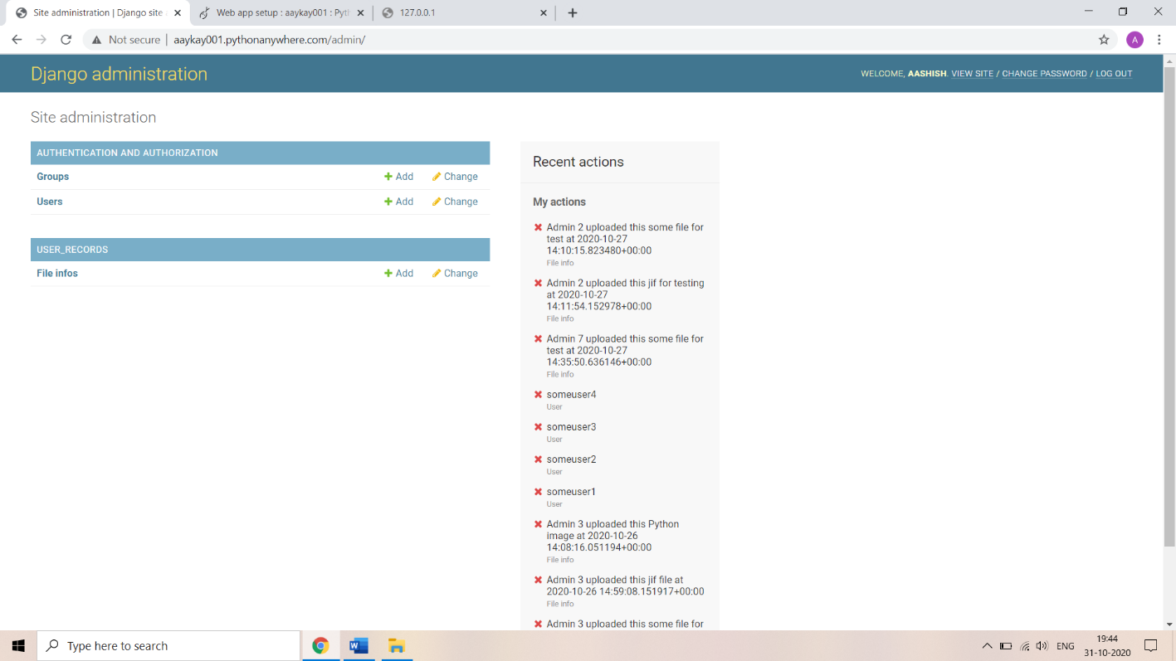

**Shared file page ( When no file is shared )**

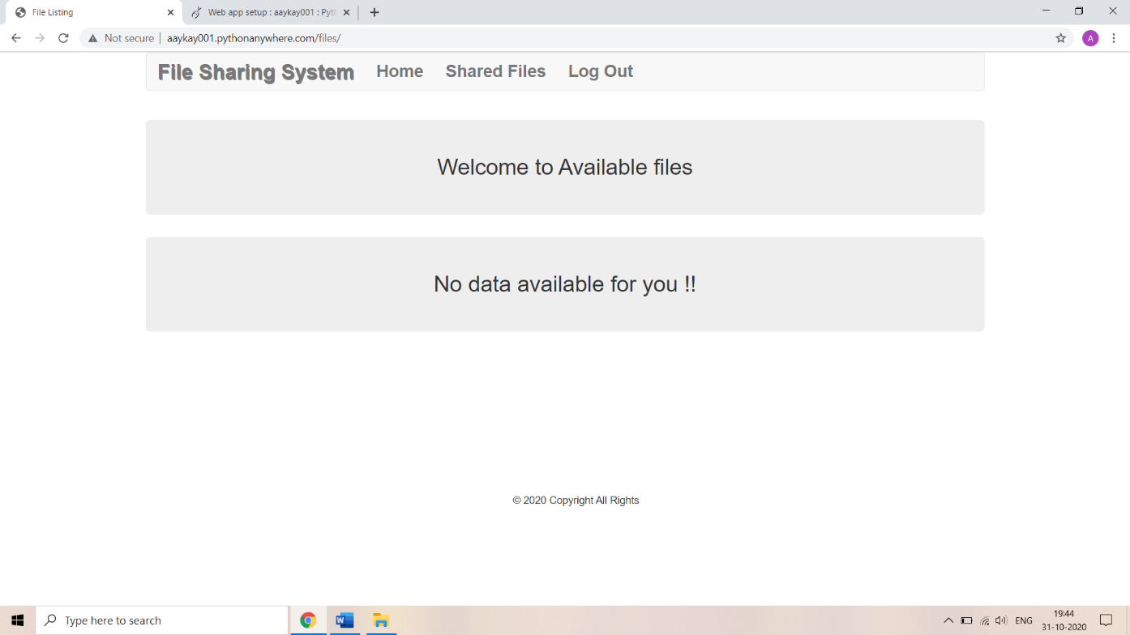

**Shared file page ( When a file is shared )**

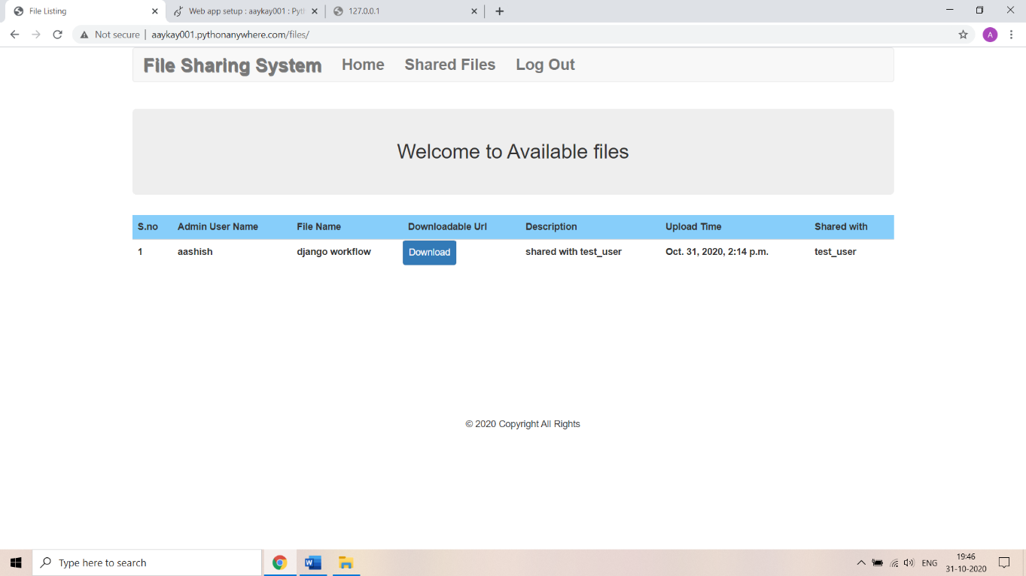

* 1. **TECHNOLOGIES AND FRAMEWORKS USED :-**
* **PYTHON :-**
* Python is a high-level, interpreted, interactive and object-oriented scripting language. Python is designed to be highly readable. It uses English keywords frequently where as other languages use punctuation, and it has fewer syntactical constructions than other languages.
* **DJANGO :-**
* Django is a high-level Python web framework that encourages rapid development and clean, pragmatic design. Django makes it easier to build better web apps quickly and with less code. Django is a registered trademark of the Django Software Foundation, and is licensed under BSD License.
* **HTML :-**
* HTML was developed with the intent of defining the structure of documents like headings, paragraphs, lists, and so forth to facilitate the sharing of scientific information between researchers. HTML is being widely used to format web pages with the help of different tags available in HTML language.
* **BOOTSRAP 4 :-**
* Bootstrap 4 is a powerful and popular mobile first front-end framework for building responsive mobile first sites on the web. It is a latest version of [Bootstrap](https://www.tutorialspoint.com/bootstrap/bootstrap_overview.htm), which uses HTML, CSS and JavaScript. Bootstrap 4 is a latest version of Bootstrap 3, who's source CSS files are converted into SCSS. It uses the flex modal for grid system and supports all the latest browsers.
* **CSS :-**
* CSS is used to control the style of a web document in a simple and easy way.CSS is the acronym for "Cascading Style Sheet".Cascading StyleSheets, fondly referred to as CSS, is a simple design language intended to simplify the process of making web pages presentable.
* **SQLITE :-**
* SQLite is a software library that implements a self-contained, serverless, zero-configuration, transactional SQL database engine. SQLite is the most widely deployed SQL database engine in the world. The source code for SQLite is in the public domain. This tutorial will give you a quick start with SQLite and make you comfortable with SQLite programming.
  1. **SWOT ANALYSIS :-**
* **STRENGTHS :-**
* Easy to operate
* Simple User Interface
* Best in terms of security ( Djnago Security )
* Free to use
* Built in admin panel
* Easy to deploy
* **WEAKNESSES :-**
* Large files takes more time to upload
* Size of the files to be uploaded is limited
* Capacity of the server to store files is less
* **OPPURTUNITIES :-**
* Easy to share files
* Reliable and safe source
* **THREATS :-**
* Memory limitations

******************************************************************************